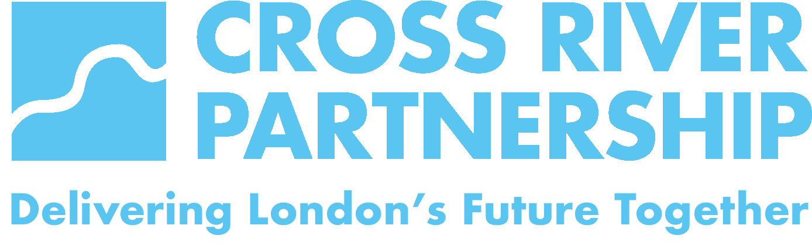

Image consent form

Cross River Partnership (CRP) will not permit photographs, video or other images of people to be taken or published without their consent.
CRP will take all steps to ensure images are used solely for the purposes they are intended.

Consent information:

- I give permission for photographs and videos that I appear in to be used within CRP printed publications, website pages, and/or social media pages.

Signature: | Print name:
Date:

Where image(s) were taken:

If the person being photographed is a child under 16, consent must be obtained from a parent, teacher, or legal guardian.

(If over 16, it’s still good practice to inform parents / teachers / guardians that photographs/videos of their child may be used if the child has given consent).

To be completed by parent / teacher / guardian:
- I give permission for photographs and videos of the named child / children below to be used within CRP printed publications, website pages, and/or social media pages.

Signature of parent / teacher / guardian: | Print name of parent / teacher / guardian:
Print name(s) of child / children:
Date:

Where image(s) were taken:

If the person being photographed cannot give consent themselves, consent must be obtained from someone known to them at the time of taking the image.

To be completed by known acquaintance:
- I give permission for photographs and videos to be used within CRP printed publications, website pages, and/or social media pages.

Signature of parent / teacher / guardian: | Print name of parent / teacher / guardian:
Print name of person begin photographed:
Date:

Where image(s) were taken:

