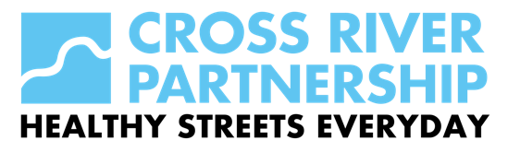
GLOSSARY

Central, Inner and Outer London:
These definitions can vary depending on the context in which they are being used. For the purposes of analysis (and future monitoring), the Mayor’s Transport strategy has used the following definitions:
- Central London: an area broadly equivalent to the Central Activities Zone (CAZ), as defined by the London Plan
- Inner London (excluding central London, as appropriate): the boroughs of Camden, City of London, Hackney, Hammersmith & Fulham, Haringey, Islington, Kensington & Chelsea, Lambeth, Lewisham, Newham, Southwark, Tower Hamlets, Wandsworth and the City of Westminster, as defined by the Office for National Statistics
- Outer London: the boroughs of Barking and Dagenham, Barnet, Bexley, Brent, Bromley, Croydon, Ealing, Enfield, Greenwich, Harrow, Havering, Hillingdon, Hounslow, Kingston upon Thames, Merton, Redbridge, Richmond upon Thames, Sutton and Waltham Forest, as defined by the Office for National Statistics

Evening peak: The period in the afternoon and evening when travel demand is highest (4pm-7pm).

Construction Logistics Plan (CLP): A travel plan that aims to improve the sustainability of construction freight movements by establishing site management and procurement processes to reduce the impact of construction traffic on the street network.

Green infrastructure: A network of green spaces – and features such as street trees and green roofs – that is planned, designed and managed to deliver a range of benefits. These include mitigating flooding, cooling the urban environment and enhancing biodiversity and ecological resilience, as well as providing more attractive places for people.

Greening:
The improvement of the appearance, function and wildlife value of the urban environment through soft landscaping.

Health inequalities: Health inequalities are systematic, avoidable and unfair differences in mental or physical health between groups of people. These differences affect how long people live in good health and are mostly a result of differences in people’s homes, education and childhood experiences, their environments, their jobs and employment prospects, their access to good public services and their habits.

Healthy routes: A TfL-funded programme of street improvements, delivered by TfL and the boroughs, to create better routes to schools and local attractions, which may include cycle parking and the implementation of 20mph limits and zones.

Healthy Streets Approach: The Mayor and TfL’s approach to prioritising people and their health in decision-making to create a healthy, inclusive and safe city for all. The approach makes London a more attractive place to walk, cycle and use public transport, and reduces the dominance of motorised transport. It uses ten evidence-based indicators, to assess the experience of being on our streets.
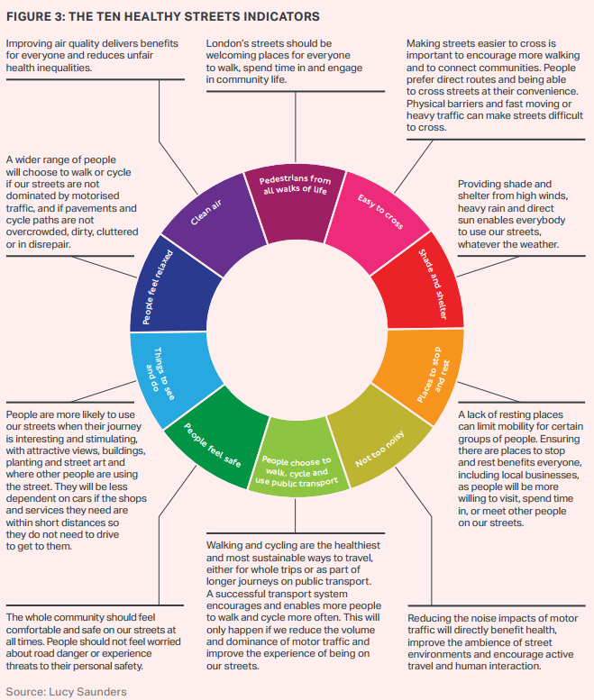

Healthy Streets Everyday: A project encompassing:
- Streetscape improvements: modal filters, pavement extensions/ improvements, continuous footways, parklets, seating, greening, public art, water fountains.
- Traffic regulations: regular timed closures (e.g. schools streets, lunchtime streets), and zero emission zones.
- Events: temporary (and scaleable) parklets, 'Dr Bike', eBike trials, evening events, including with the Illuminated River project and arts and cultural institutions along the Thames. Alignment with Clean Air Day (June) and International Car Free Day (22 September).

Journey stage: Part (or sometimes all) of a trip made by a single mode of transport. A home-to-work trip, for example, may contain three journey stages: a walk to a bus stop, a bus journey stage, and a further walk from the bus stop to the workplace.

Legible London: A map-based walking wayfinding and information system that gives people clear and consistent information to facilitate and encourage walking journeys. It is managed by TfL but available for third-party use.

Liveable Neighbourhoods: A TfL-funded programme, delivered by TfL and the boroughs, to improve the public realm and the experience of walking, cycling and using public transport while increasing opportunities to use streets as public spaces and reducing car trips.

Local Implementation Plan (LIP): A statutory transport plan produced by London boroughs, which brings together transport proposals to implement the strategy
at a local level.

Low Emission Zone (LEZ): A charging zone across most of Greater London for vehicles that do not meet emissions standards for particulate matter.

Mayor’s Air Quality Fund: Funding from the GLA to London boroughs to support a wide range of projects aimed at improving air quality.

Mixed-use development: Development for a variety of activities on single sites or across wider areas such as town centres.

Nitrogen dioxide (NO2): A gas formed by combustion, identified as an air pollutant harmful to human health. The legal limit values measure concentrations of NO2 in the air.

Nitrogen oxides (NOx): A generic term for nitrogen dioxide (NO2) and nitrogen monoxide (NO) – the latter can form NO2 in the atmosphere. Euro standards set NOx vehicle emissions limits.

NRMM Low Emission Zone: An area of London subject to regulation of NRMM emissions, as defined by the GLA’s Supplementary Planning Guidance, ‘The Control of Dust and Emissions from Construction and Demolition’.

Particulate matter (PM): A mixture of various solid and liquid particles of various chemical compositions suspended in the air.

Play Streets: Regular, timed road closure so children can play out, can be promoted with one-off street party events, but are (usually) different Traffic Orders from one-off event (RTRA 1984 s.16a vs RTRA 1984 s.29).

PM2.5: Particulate matter that is 2.5 microns or less in diameter. Particulates of this size are small enough to penetrate deep into the lungs and other organs, causing a wide range of health impacts, and are therefore subject to legal limit values.

PM10: Particulate matter that is 10 microns or less in diameter. It is harmful to human health and subject to legal limit values.

Public realm: Publicly accessible space between and within buildings, including streets, squares, forecourts, parks and open spaces.

School Streets: Regular timed traffic restrictions, Timed pedestrian and cycles only zone, 5 days per week, Residents exempted, Vehicles already in the zone can leave, Installation of large signs at all entry points which fold up during non-operating periods.

Traffic reduction strategy: Borough-led strategy to reduce car and freight traffic at a local level, developed as part of LIPs.

Transport assessment: A process that sets out transport issues relating to development proposals.

Ultra Low Emission Vehicle (ULEV): Vehicle with reduced emissions of air pollutants and CO2, including battery electric, hydrogen fuel cell electric, plug-in hybrid and range-extended electric vehicles.

Ultra Low Emission Zone (ULEZ): Charging zone in which vehicles that do not comply with emissions standards for air pollutants will be subject to a daily charge.

Vehicle Excise Duty (VED): A tax (also known as ‘vehicle tax’, ‘car tax’, and ‘road tax’) that is levied as an excise duty. It must be paid for most types of vehicles being used (or parked) on the public roads in the United Kingdom.

Vision Zero: An approach to road danger reduction that works towards the elimination of road traffic deaths and serious injuries by reducing the dominance of motor vehicles on London’s streets.

Vulnerable road user: A person travelling on foot, by cycle or by motorcycle, who is disproportionately affected by road danger in London. Vulnerable road users make up 80 per cent of those killed or seriously injured on London’s streets.

Zero carbon: Activity that causes no net release of carbon dioxide and other greenhouse gas emissions into the atmosphere.

Zero emission capable (ZEC) vehicle: A vehicle that is constructed to be capable of operating in zero emission mode for at least part of its operating cycle. The zero emission mode may be augmented by an internal combustion engine configured to extend the driving range of the vehicle, either by propelling the driven wheels or by powering an on-board generator.

Zero emission transport: Transport that produces zero harmful exhaust emissions, including PM, NOx, NO2, CO and CO2.

Zero emission zone: A zone within which vehicles not capable of operating with zero-pollutant exhaust emissions are subject to road user charges (similar to ULEZ or LEZ) and/or other vehicle prohibitions or restrictions.

