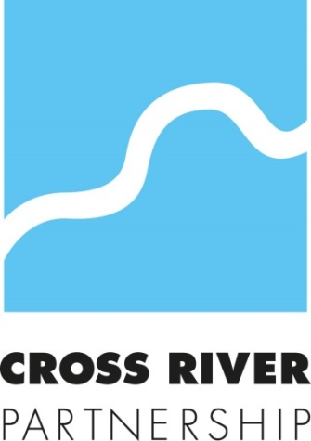

Consultation: Culture Strategy

Response from Cross River Partnership (CRP)

12th June 2018

Submitted by email to: CultureConsultation@london.gov.uk

VIEWS AND INFORMATION
The views expressed in this submission are on behalf of Cross River Partnership (CRP) staff as a group of professionals with expertise in urban regeneration and sustainability projects and do not necessarily reflect the views of our funding and Board partners.

In this response CRP is not promoting solutions to the issues being addressed; only suggesting opportunities which could be investigated in the context of central London.

CRP’s response to the Mayor’s Culture Strategy sits alongside responses it has already submitted to the new London Plan and Mayor’s Transport Strategy, Skills for Londoners Strategy, Environment Strategy, Health Inequalities Strategy, Economic Development Strategy, as well as the 24 Hour London Vision.
For further information on any of the comments made in this document, please do not hesitate to contact:
Susannah Wilks, Cross River Partnership Director
susannahwilks@crossriverpartnership.org

CONTACT DETAILS
Cross River Partnership
6th Floor
5 Strand
London
WC2N 5HR
crossriverpartnership.org
@CrossRiverPship
Phone: 020 7641 2198

WHO WE ARE
Cross River Partnership (CRP) is a public-private partnership that has been delivering regeneration projects in London since 1994.

CRP is currently delivering a range of regeneration programmes in the central London sub-region, which each contribute to the achievement of one or more of these objectives.

- Good Jobs
- Strong Business
- Clean Air
- Great Places

CRP is a voluntary association of local authorities, business organisations and other strategic agencies relevant to London. We deliver programmes alongside Transport for London, the Greater London Authority, central London boroughs, and Business Improvement Districts (BIDs).

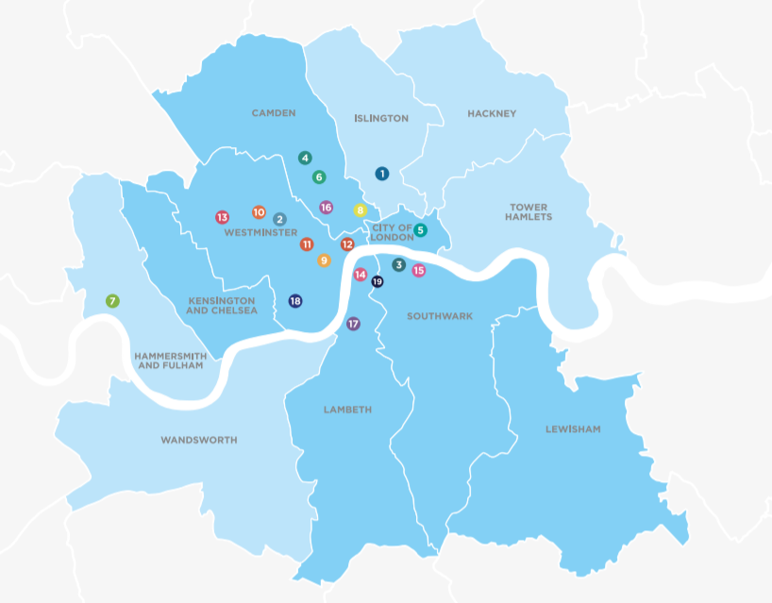
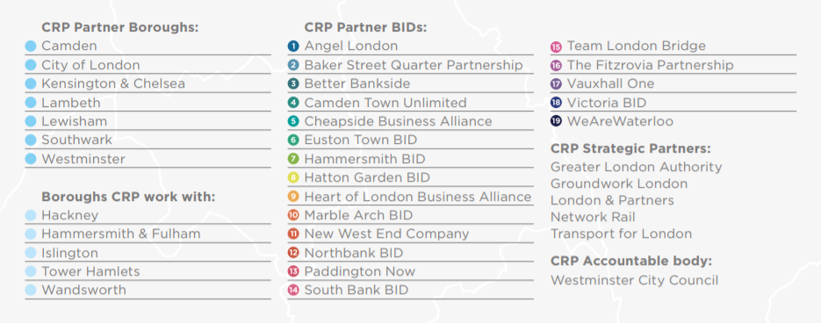

With this partnership, CRP is uniquely placed to coordinate businesses, boroughs, and community groups who call London home to deliver employment, community cohesion, culture, good growth, environmental sustainability, transport, place and other interventions.
Cross River Partnership is a strong supporter of culture and links it through all of the projects that it delivers.

CRP’s Light at the End of the Tunnel used art to develop routes under railway arches to enliven and activate new areas; and CRP is providing advisory support to the Illuminated River project. CRP’s Sustainable Urban Markets project has supported markets to develop their offering more efficiently to help maintain these valuable local community and cultural hubs across London. This programme recommended the creation of the London Markets Board.

CRP is now communicating about air quality through cultural activities with our Business Improvement District and Borough partners to bring the subject to life and support people to reduce their exposure to air pollution.

Information on CRP’s projects and programmes can be found in Appendix A.

The Mayor’s Culture Strategy

CRP’s welcomes the Mayor’s Culture Strategy, and our response to the consultation questions are set out below.
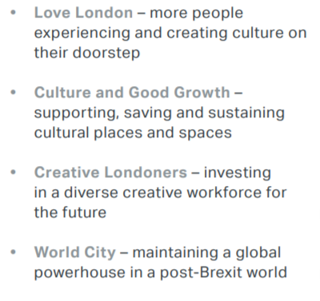

Q1 What impact does the capital’s culture have on quality of life for Londoners? What could the Mayor do to amplify and support these areas?

The Mayor’s strategy highlights many of the ways in which culture supports communities, cohesion, industry, economy, jobs, health, wellbeing, cognitive development, journeys and makes London an interesting and exciting city to visit, work and live in.

The Mayor’s focus on place-based cultural interventions such as Borough of Culture, and Creative Enterpise Zones will support and enhance areas with the potential to be vibrant cultural centres. The Mayor should consider how these zones can be linked, creating corridors and easily accessible (geographically, socially and intellectually) culture for all; through all media; to enable everyone to enjoy London’s culture.
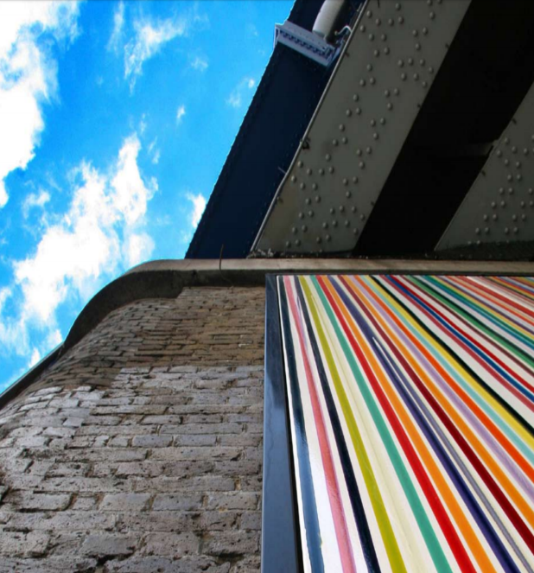
Figure 1 CRP's Light at the End of the Tunnel
Culture can be used to change the ways in which people use and enjoy the city, drawing people to forgotten spaces, and signposting them to new areas.

The culture strategy should ensure it considers a wider definition of culture to include religion and sporting/recreational activities. Particularly including active travel, linking the value that culture has in providing interesting things to see and do to support the creation of healthy streets.

Light at the End of the Tunnel

CRP’s Light at the End of the Tunnel project reimagined space, using art, culture and new business to tackle the severing effect of disused railway tunnels, and reducing London’s north South divide.

Q2 Do you agree that London must embrace a broad definition of culture that includes less formal places and spaces? If yes, what could the Mayor do to best support informal culture?

Yes.

This exceedingly important to improve accessibility to culture. Culture means many different things, to different people. Informal culture can enliven places and spaces, and draw communities together. It also provides interest for visitors to London, drawing them to other areas for a different view of the city.

To support informal culture, the Mayor should ensure that culture is embedded in all aspects of activity at the GLA and within Transport for London. It will also be important to facilitate boroughs in linking their officers that deliver culture with teams that are responsible for employment, transportation, sustainability and more to deliver on this strategy’s promises.

The Mayor must also ensure that boroughs that have not received large-scale, flagship funding like Borough of Culture, and Creative Enterprise Zones, have access to other funding to support development of culture, coordinated throughout the city by boroughs that have specific knowledge of the areas and communities that are currently not able to access culture. Informal culture could in particular be supported by crowdfunding, enabling grass-roots, locally owned culture to flourish.

To be truly accessible, culture should be everywhere, in schools; hospitals; workplaces; religious centres; and other places that people regularly visit. The strategy should further reference how this approach will be implemented.

Q3 How could the Mayor help to remove barriers that prevent all Londoners from securing creative jobs? What examples of good practice are you aware of in this area?

Creative jobs must be accessible to all. To increase diversity in the sector, jobs must be flexible, and lesser known ‘behind the scenes’ roles publicised better. Projects which specifically target disadvantaged groups are also of great importance. For example, through CRP’s CamdenAbility project we are increasing the number of jobs available for Camden residents with disabilities and health conditions, working closely with employers and the Business Disability Forum to do this. A specialist and personalised service is being provided to the candidates accessing the project, and we are working alongside employers to and the Business Disability Forum to access vacancies and ensure appropriate support is in place to meet the needs of our candidates.

Recruit London
Cross River Partnership’s Recruit London initiative works directly with employers to support them to recruit locally and diversity their workforce. Alongside this, candidates receive job-focused support and benefit from opportunities secured from employers which help them develop their skills, knowledge or confidence. This includes work placements, site tours, and employer insight sessions. The central London candidates supported are workless and may face other barriers to employment such as disabilities or long term health conditions, homelessness or caring responsibilities.
CRP has worked with cultural organisations, and previously had a Workplace Coordinator based within Tate Britain to support their recruitment. More recently we have worked with the Royal Opera House, running site tours for groups of job-seekers which helps them to understand the careers available within a cultural organisation they may never have considered or visited. We have successfully placed a candidate into a front of house role within ROH who had been out of work for health reasons, and was referred via the Central & North West London NHS Trust. Working with The Foundling Museum, we support candidates into volunteering opportunities as room guides, which give them the opportunity to develop their confidence and customer service skills before progressing to paid work.

CamdenAbility

Through our CamdenAbility project we have created a network of employers committed to becoming more disability smart. Partnering with the Business Disability Forum, members have access to disability awareness training; networking and knowledge sharing events; and consultancy. We have worked with them to open up work placements and vacancies within their organisation for local disabled residents. The network comprises over 20 cross sector employers in Camden including Waitrose, Caterlink, University College London, Unison, The Francis Crick Institute and Laing O'Rourke and Apleona.

After engaging local residents with disabilities and long term health conditions, our Workplace Coordinator carries out a comprehensive work-focused assessment, then provides the support needed including boosting confidence and motivation before placing candidates into work placements and jobs. We work with employers to advise on any adjustments needed to help the candidate succeed, and continue to offer support to both the employer and candidate once they have started. The project is funded by Camden Council.
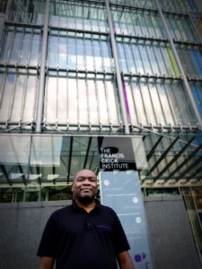
CamdenAbility

Joseph, 39, has a learning disability and had never worked before registering with CamdenAbility. We engaged Joseph, worked with him to understand his career ambitions and provided one-to-one support.

Due to his preference for a cleaning job, we brokered a role with CamdenAbility member Apleona, a cleaning and maintenance contractor at the Francis Crick Institute.
Apleona agreed to implement a flexible approach and adapted their normal recruitment process, removing a number of barriers presented by the process for applicants with additional needs. Rather than relying entirely on the results of a competency based interview, Apleona met with a local CamdenAbility candidate, Joseph, for an informal meeting, progressing to a short work trial where he was able to demonstrate his ability, and be assessed for the role. After the successful work trial, he was offered a permanent position and began working. We advised Apleona on small adjustments needed in order for Joseph to understand and fulfil his daily tasks.

CRP’s innovative disability employment initiative CamdenAbility delivered in partnership with Business Disability Forum, is funded by Camden Council and supported by the Department of Work and Pensions. For more information visit: crossriverpartnership.org/news/camdenability-and-the-francis-crick-institute/

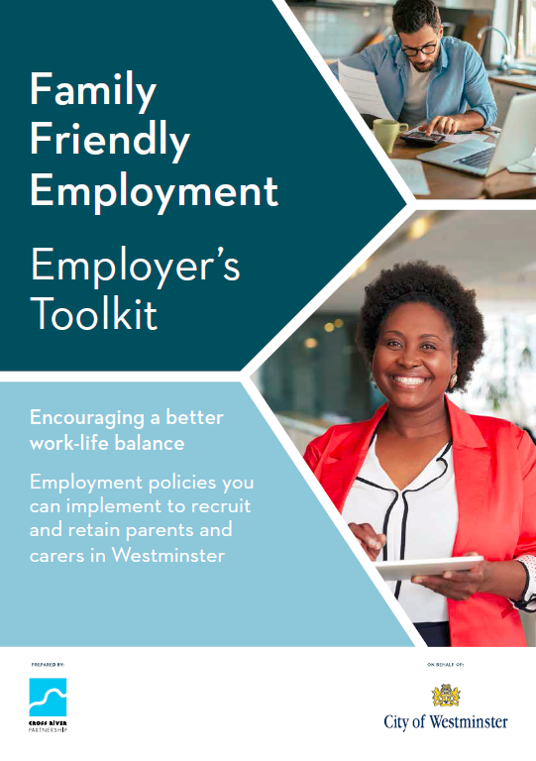
Family Friendly Employment Toolkit
Cross River Partnership developed a Family Friendly toolkit to highlight good practice in family friendly employment policy, to help businesses to recruit and retain parents and carers.

The document sets out the business case for becoming more family friendly. This helped employers to understand the wide range of policies they could adopt to support this group. Many cultural and creative employers participated in the project including The National Gallery; Royal Opera House; Tate; Exhibition Road Cultural Group; theatre company Improbable; and ticketing, marketing and fundraising software company Spektrix.

CRP would welcome the opportunity to prepare a Diversity in
Employment Toolkit with and for the Culture Sector.

To view the toolkit please visit:

https://crossriverpartnership.org/media/2016/11/Family-Friendly-All-Documents-Final2.pdf

Q4 How can the Mayor increase participation in the arts and cultural life of the capital, particularly for people who don’t currently have access to it? Who should he be partnering with?

Culture must be available across the city, in all boroughs, near to where people live, to ensure easy access for all. To encourage this, more could be made of an ad-hoc approach to culture; bringing it to high streets, on commutes (particularly around active travel), to parks and importantly in schools. Funding that is available, such as Borough of Culture, Creative Enterprise Zones, and good growth Fund is very much place-based. Thought should be given to how these geographically restrictive programmes can be extended, what the reach is of creative zones, and how they can be linked together to create culture paths throughout London.

CRP welcomes the desire to encourage new creators of art; from all backgrounds, to ensure there is culture for all. The strategy could increase the recognition that younger generations in particular increasingly access culture through different media. This includes television and the internet, and the Mayor should consider how these media can best be used to build community and encourage participation.

The Mayor should partner with multiple organisations as stated within the strategy. It is great to see that the Mayor is developing relationships with BIDs to support culture on high streets and healthy, interesting streets. There is ample opportunity to bring culture into other topics and aspects of city life too.

In addition to those stated, CRP is a strong sub-regional public/private partnership that is well placed to deliver programmes across central London, bringing a wealth of partners together to deliver a coordinated approach. CRP also has strong communication networks in central London, bringing together boroughs, businesses, BIDs, landowners, HEIs and residents to deliver amazing partner-owned projects.

Clean Air Together

Cross River Partnership is hosting an exhibition at New London Architecture to highlight the importance of partnership working to deliver clean air for London. The exhibition uses photography to engage people and enliven the topic.

For more information visit: https://crossriverpartnership.org/projects/clean-air-together/

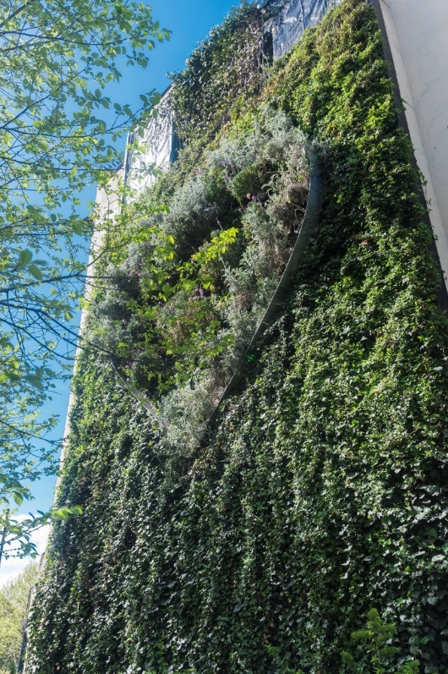
Figure 2 CRP's Greening the BIDs programme, Royal Vauxhall Tavern, delivered by Vauxhall One BID
Q5 What other opportunities are there to support culture in the capital?

It is fantastic that the Mayor has highlighted the importance of health and wellbeing benefits that are realised from access to, creation of and use of culture. This in particular should be linked with the Mayor’s plans for a National Park City, recognising the health and wellbeing benefits that green and blue infrastructure brings too. As stated in the strategy, the Mayor’s approach to greening as part of culture is great to see. Parks and green spaces should also host art and culture, which can include sporting and recreational activities.

Q6 How can you or your organisation contribute to the Mayor’s vision for culture and pledge to support the final strategy?

Cross River Partnership can support improving diversity in employment in the Cultural Sector.
Our Workplace Coordinators work with a wide range of local partner organisations to engage residents then provide training and support focused on the jobs available. Alongside this they work with local employers, including cultural organisations, to access their job vacancies, encouraging them to change their assessment techniques to make them more inclusive to our candidates (including long-term unemployed, people with disabilities and mental health illness and people with caring responsibilities) and recruit based on potential rather than experience and qualifications. This gives candidates a foot in the door they would not have if applying through usual routes with lengthy online application forms, rigid entry requirements and automated screening processes. We continue to provide support to both employers and candidates for six months after they start in work to help make placements a success. Cross River Partnership could develop a specific programme on behalf of the Mayor to deliver specific support to people entering the creative industries, matching people to the specific needs of employers.
For more information visit: https://crossriverpartnership.org/projects/recruit-london/

Cross River Partnership has also led many projects, funded by boroughs, BIDs, the Mayor’s Air Quality Fund and Defra, to tackle London’s air pollution. CRP could develop a specific programme focussing on tackling air pollution in areas around specific creative and cultural heritage sites that are particularly susceptible to poor air quality. CRP engages with businesses, boroughs, and residents to achieve step change in air pollution levels, and reduce exposure to emissions.
Delivery Servicing Plans

Cross River Partnership has worked with many iconic London culture venues to support them to review their deliveries and servicing to reduce their negative impacts on local air quality. For example, CRP has worked with Exhibition Road Museums, Roundhouse, St Martin-in-the-Fields.

For more information visit: https://crossriverpartnership.org/projects/clean-air-together/ and
https://crossriverpartnership.org/projects/clean-air-better-business/

Sustainable Urban Markets

CRP’s Sustainable Urban Markets project has supported markets to develop their offering more efficiently to help maintain these valuable local community and cultural hubs across London. This programme led to the creation of the London Markets Board. CRP is well placed to support local markets to maximise their cultural potential.

For more information visit: https://crossriverpartnership.org/projects/sustainable-urban-markets/

Cross River Partnership can also deliver events; projects; community/play streets; support sustainability in cultural industries.
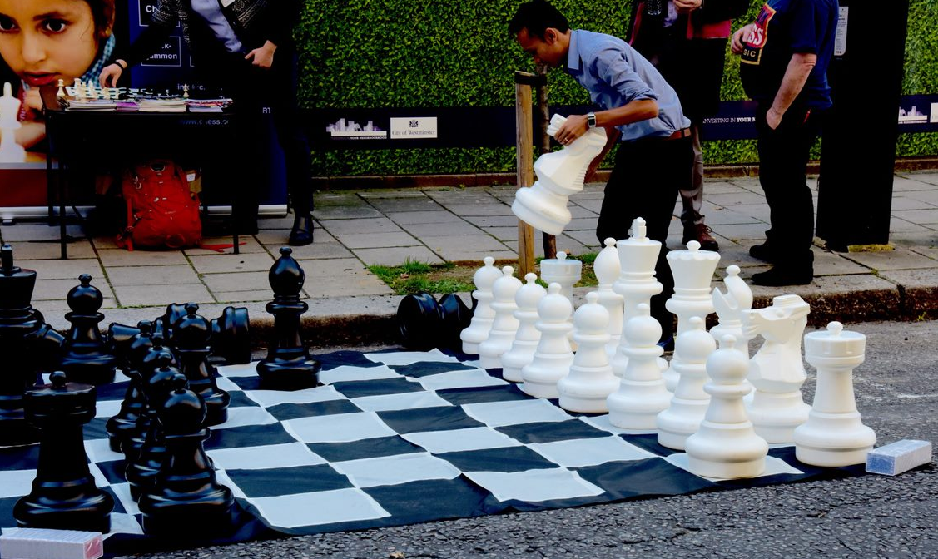
Figure 3 A CRP organised Community Green Street for the Marylebone Low Emission Neighbourhood on World Car Free Day, 2017

About our organisation

Name of organisation: Cross River Partnership
Type of organisation: Other
Sector: Public/Private Partnership
Geographic area of focus: Local, focusing on central London – Camden, City of London, Lambeth, Lewisham, Kensington & Chelsea, Southwark, Westminster

Contact details
Susannah Wilks
susannahwilks@crossriverpartnership.org
Director
0771 444 7465
5 Strand, London WC2N 5HR
www.crossriverpartnership.org

We confirm that we are happy to be contacted on behalf of the GLA about any future actions related to the Mayor’s Culture Strategy.

Appendix A

How CRP operates
CRP develops, fundraises for and delivers programmes that add value at a sub-regional level to the individual activities of its public and private partners.

CRP delivers projects via a number of programmes targeted at addressing various social, community, health, business and environmental regeneration issues in central London. The following is a summary of programmes delivered:

Recruit London
Recruit London is a free local recruitment service for businesses. Our workplace coordinators train and place out of work residents into jobs across central London. Our recruitment service appeals to the following groups:
Employers
The Recruit London service is free to employers and CRP offers up to six months of work place mentoring, mock interviews and a tiered assessment process; with all sectors of business including cultural sector.
Partners
Our referral partners include a number of Business Improvement Districts, charities, the Job Centre and the Business Disability Forum. The relationship works a number of ways: we provide and receive candidates, and provide workplace coordinators to conduct work placement days onsite when a number of vacancies need to be filled.
Jobseekers
Our workplace coordinators get to know jobseekers so they can match skills with suitable full and part-time vacancies, for paid jobs, apprenticeships, work experience and other work opportunities.

Light at the End of the Tunnel
CRP Facilitated the installation of award winning physical realm art and lighting around 60 Southwark and Lambeth railway viaducts / tunnels to spread growth into previously under-used areas. Space was made available to creative business and CRP worked with artists to implement innovative lighting in tunnels to increase footfall, walking, cycling, permeability, access and safety / crime reduction.

Sustainable Urban Markets
A Strategy and 28-point Action Plan (including GIS mapping) for the central London sub-region (on behalf of boroughs of Camden; Islington; City of London; Southwark; Lambeth; Wandsworth; Kensington & Chelsea; Westminster) on the contribution that street and covered markets can make to all aspects of urban regeneration, including culture-led regeneration. Pre-cursor to pan-London strategy and setting up of the Mayor’s London Markets Board. Plus a Strategy and Action Plans for 3 central London markets on how to manage their Markets Deliveries and Servicing so that the markets can be as attractive as possible for tourists, residents and employees, and generate growth and prosperity in local areas;

Illuminated River
Development and advisory work to set up The Illuminated River Foundation and project concept, alongside the GLA and The Rothschild Foundation;

Greening the Business Improvement Districts (BIDs)
Over the past five years, supported by seed funding from the Mayor of London, Drain London Fund and Natural England, Cross River Partnership has coordinated The Greening the BIDs Steering Group, bringing together Business Improvement District to deliver 19 Green Infrastructure Audits and 16 GI installations, including rain gardens, green walls and green roofs, across central London. The Living Wall on the side of the Rubens Hotel in Victoria is one high profile example.

Central London Sub Regional Transport Partnership (CLSRTP)
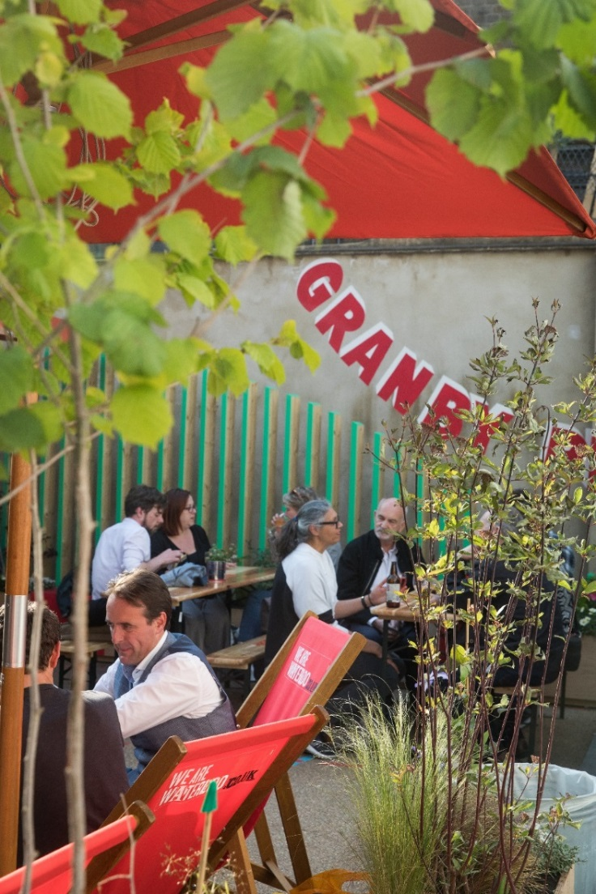
CRP facilitates this partnership of the eight central London boroughs (Camden, City, Islington, Kensington and Chelsea, Lambeth, Southwark, Wandsworth and Westminster) on behalf of Transport for London. The partnership undertakes research and trials innovative schemes involving both Local Authorities and BIDs to support growth and place making, encourage uptake of active and sustainable transport modes, improve air quality, use art to open places and make the transport system more efficient. The partnership is facilitating the installation of art on Ravenet Street in Wandsworth to open up walking routes, and is developing a toolkit in using culture in urban realm projects.
Figure 4 Using green infrastructure to enliven and bring culture to unloved spaces. We Are Waterloo BID delivered for CRP's Mayor's Air Quality Funded Clean Air Better Business Programme

Clean Air Better Business (CABB)
Fresh from the success of Clean Air Better Business Phase 1, CRP is now delivering Clean Air Better Business Phase 2 with 18 inner London boroughs and BID partners, funded by the Mayor’s Air Quality Fund. An exciting programme of collaborative behaviour change activities is being delivered with businesses including the Roundhouse; St Martin in the Fields and many more cultural organisations.

Freight Electric Vehicles in Urban Europe (FREVUE)
CRP was the lead partner for this 30-strong trans-national partners Programme to trial different sizes and types of freight electric vehicles across 8 countries across different climates, industry sectors and policy environments. Detailed statistical results are available showing the real contribution that freight electric vehicles (including large electric vehicles) could make to air quality and a cleaner London. In particular, vehicles can be used around heritage and historical culture sites where air pollution is a significant problem and could cause damage.
This programme was funded by the European Union’s Seventh Framework Programme.

West End Partnership Freight Programme (WEP)
As part of this work, WEP have set up Freight Group to pull together all the current projects working to reduce freight. CRP has developed a Freight & Servicing Strategy with stakeholders that will ensure that enough is being done to keep the West End moving, with goods and services coming and going efficiently. The programme looks at reduction, re-timing and consolidation of freight movements, in addition to increasing ultra-low emission vehicle projects to deliver commercial, health and air quality benefits. The group includes boroughs, Business Improvement Districts, businesses including the Royal Opera House.

deliverBEST
Cross River Partnership has developed an online tool that enables businesses to very quickly identify relevant actions they can take to improve the efficiency of their deliveries, save money, reduce congestion and cut air pollution. www.deliverbest.london has been developed based on CRP’s experience working with over 50 businesses across central London and Europe.
CRP’s deliverBEST business engagement team also support business to act on recommendations made by delivering bespoke 1:1 support, providing implementation insights, measuring results, and creating case studies to promote the impact of actions taken.

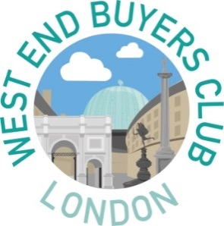
West End Buyers Club
Cross River Partnership developed the West End Buyers Club (www.westendbuyersclub.london) shared supplier scheme for New West End Company. The tool has been reducing the number of waste and office supplies delivery trips across the West End and is now being rolled out across a wider geographical area, to cover additional Business Improvement District Areas and the Marylebone Low Emission Neighbourhood.
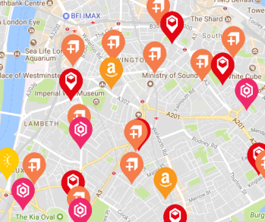
Click. Collect. Clean Air.
‘Click and collect’ services such as Amazon Lockers, Doddle and Parcelly consolidate parcel deliveries and divert unnecessary deliveries from congested and polluted high streets, especially personal deliveries. But the range of services on the market can be confusing, and many people are unaware just how easy, convenient and affordable ‘click and collect’ can be.
CRP’s website www.clickcollect.london explains how the different click and collect services work, maps parcel collection points across London and the U.K., and provides free trials of premium options, making it easy for online shoppers to test alternative delivery options. A behaviour change campaign with materials including leaflets, posters and videos supports businesses to promote alternatives to workplace deliveries to their staff.

